Connecting MySQL workbench to AWS RDS.

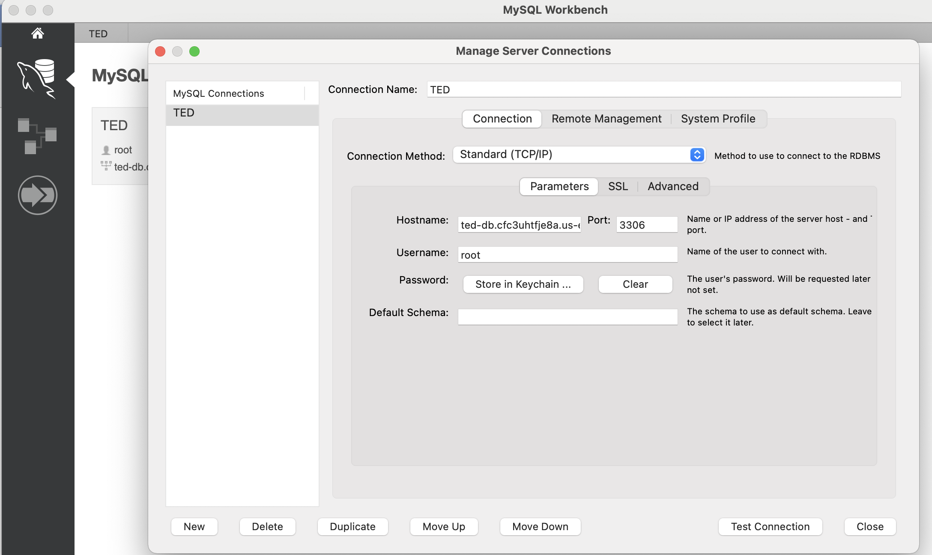

Creating TED Database; creating tedshows & tedauthor tables. 🡪 load the data into them.

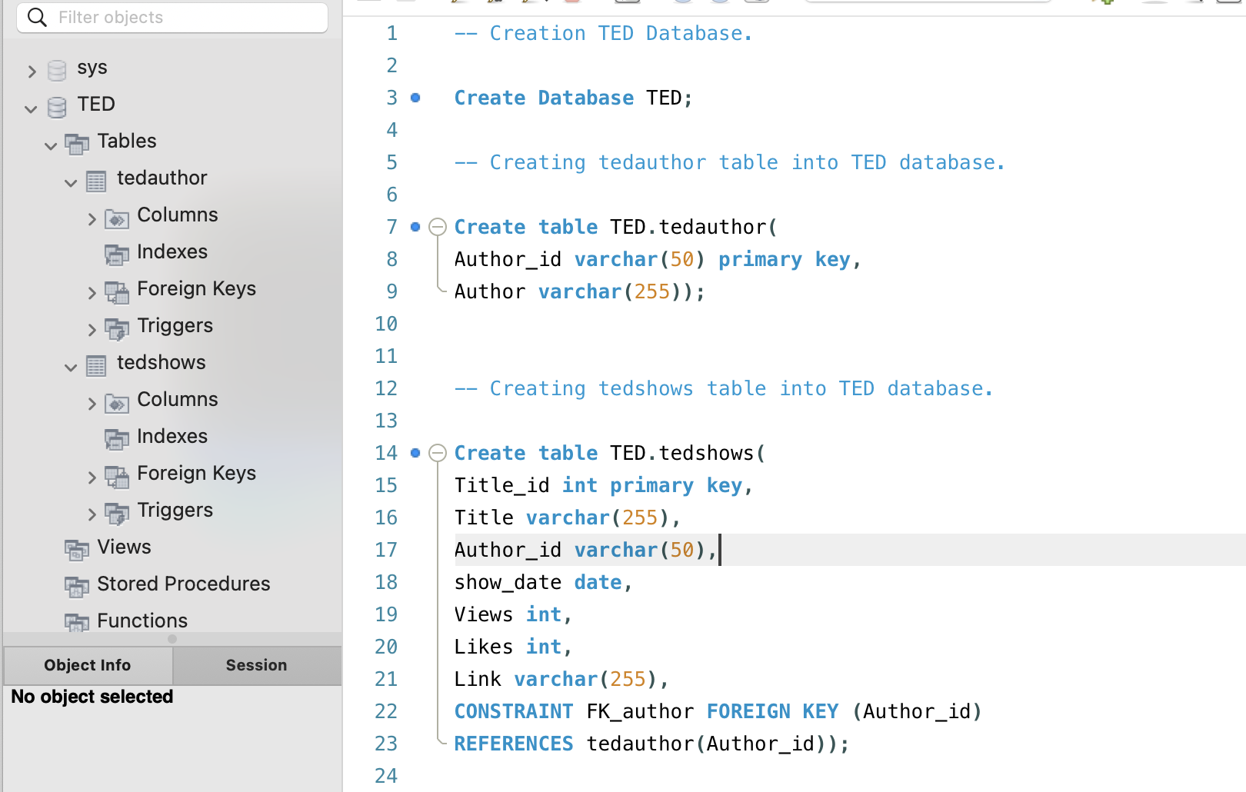

Query1: To Find the top 10 popular ted talk shows based on Views

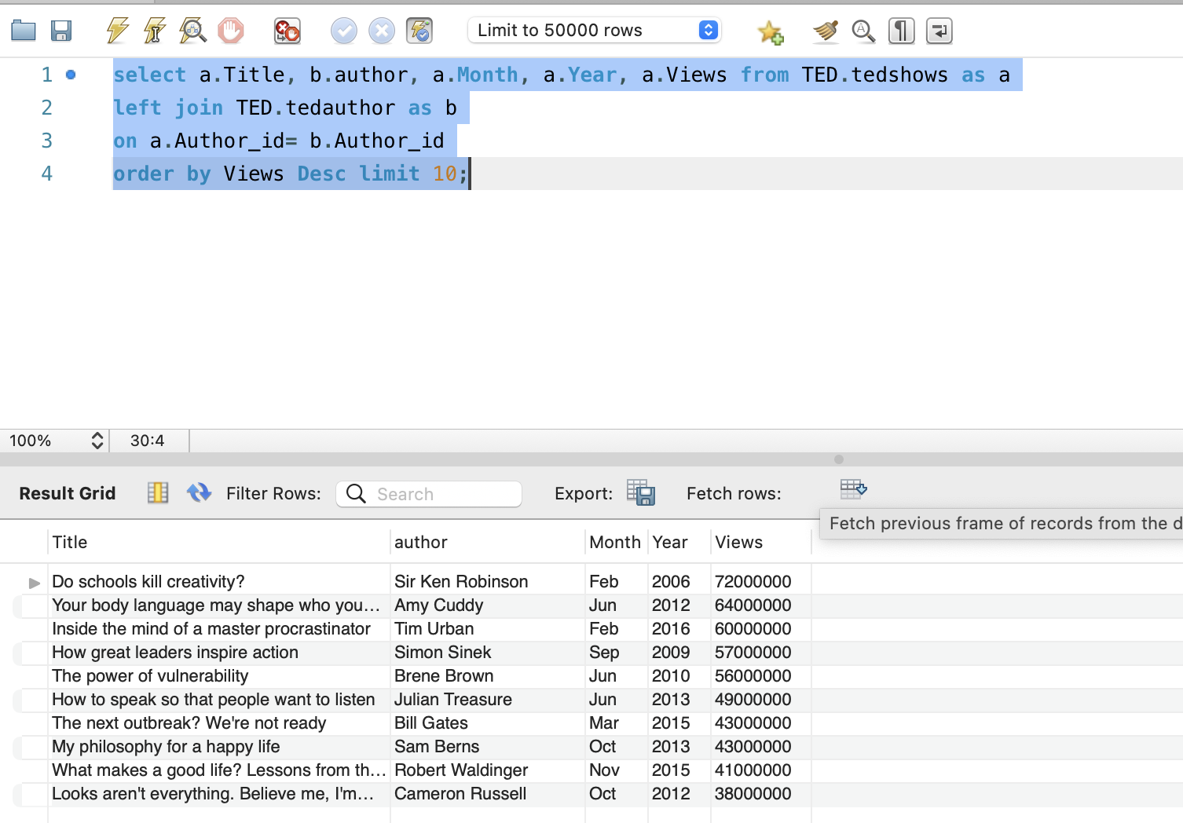

Query2: Top 20 popular shows in 2020 to 2022 years.

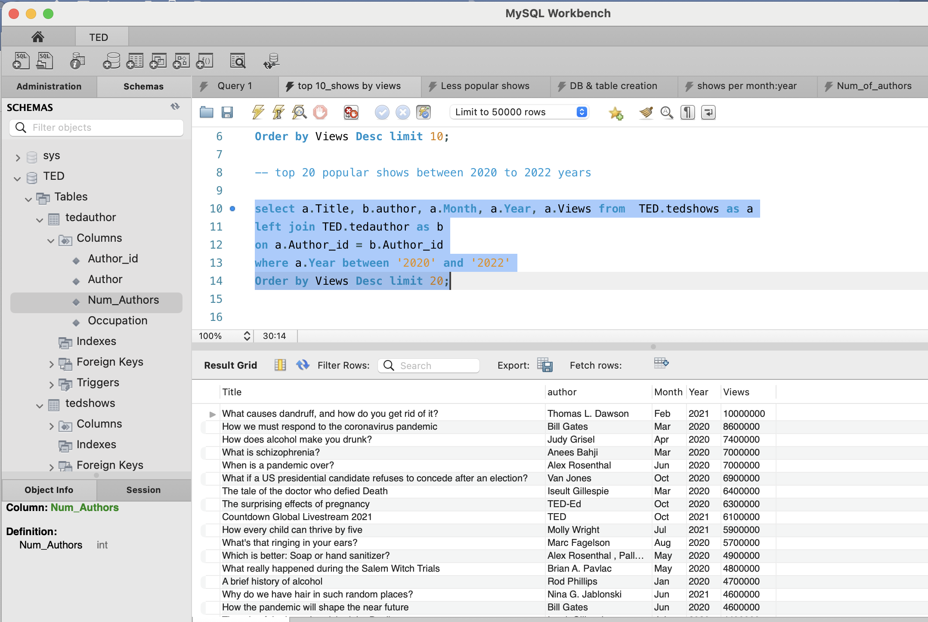

Query3: Top 10 popular ted talk shows based on Likes.

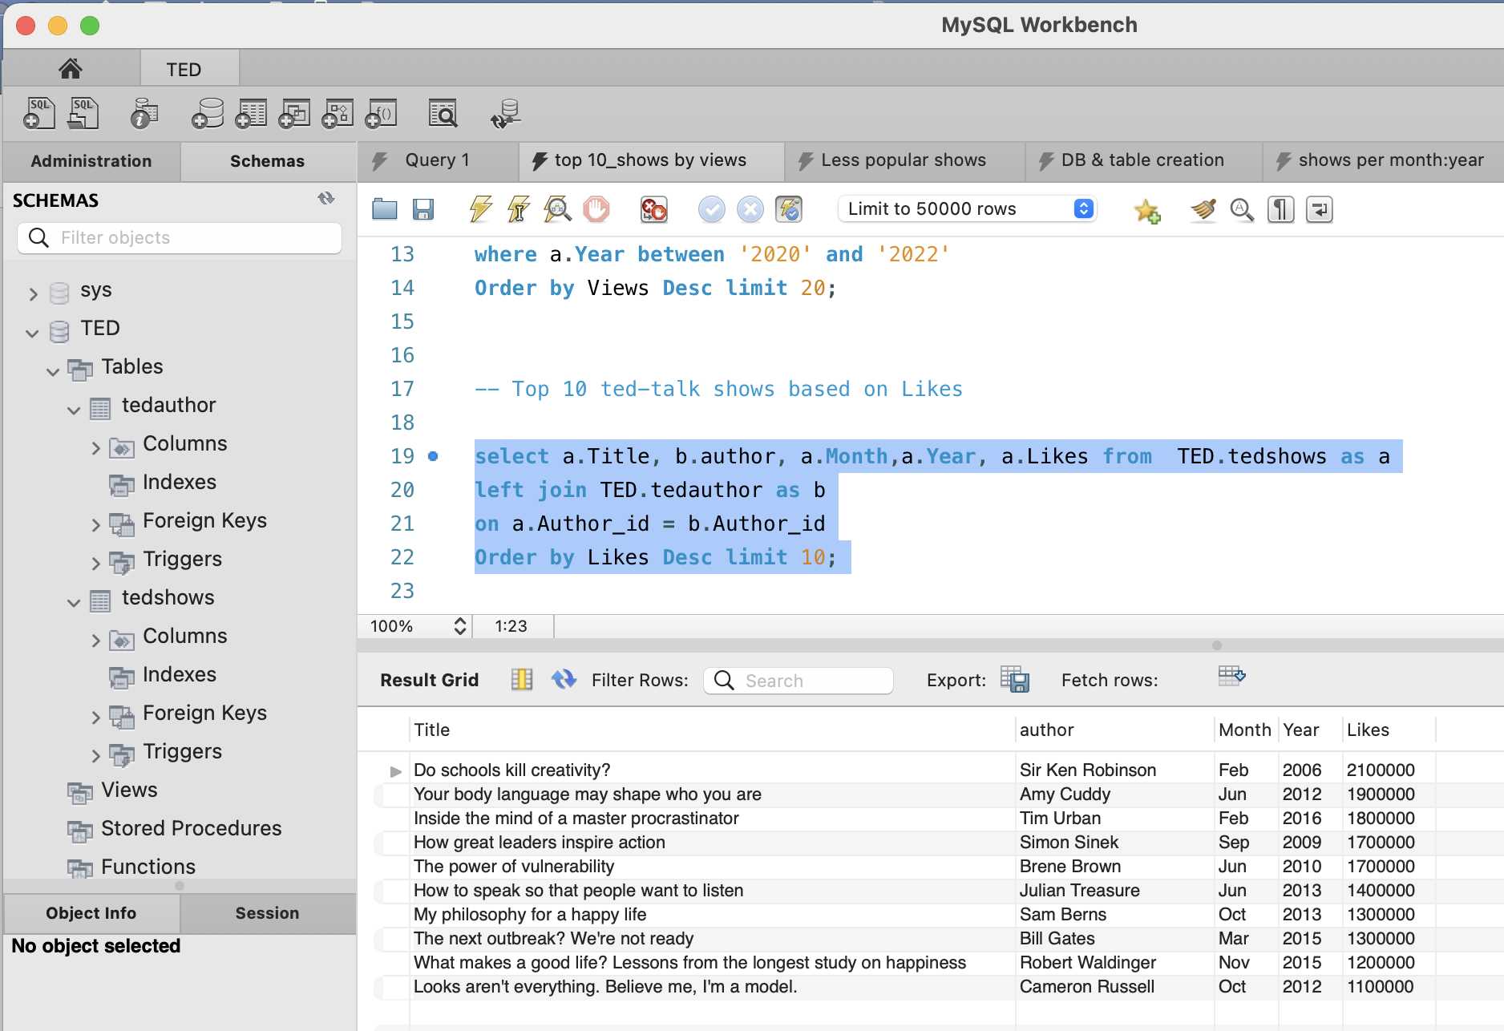

Query4: top 100 shows which are less popular based on views and likes.

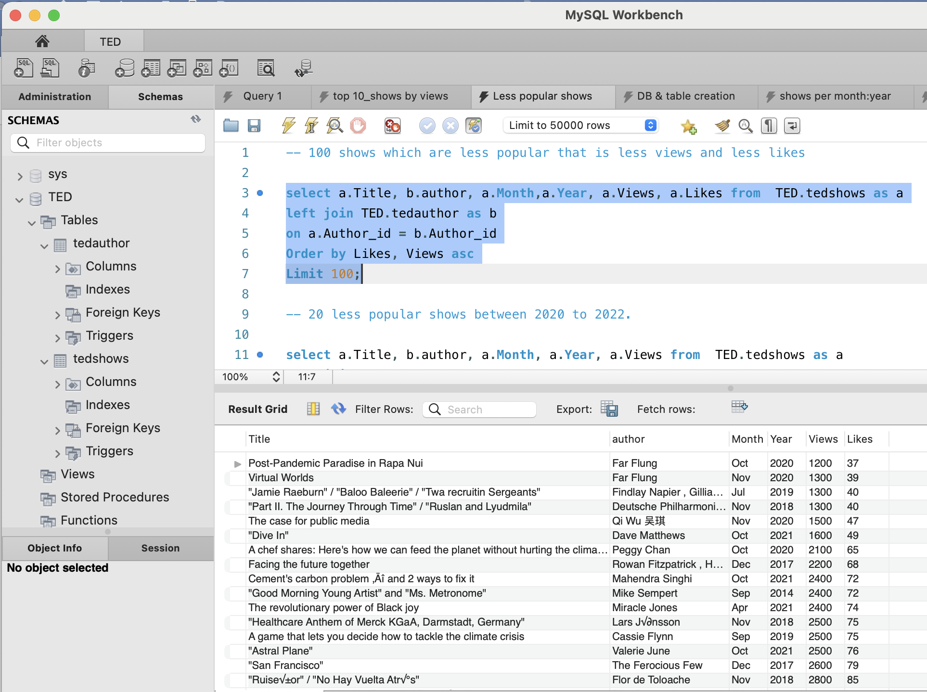

Query5: top 20 less popular shows in 2020 to 2022.

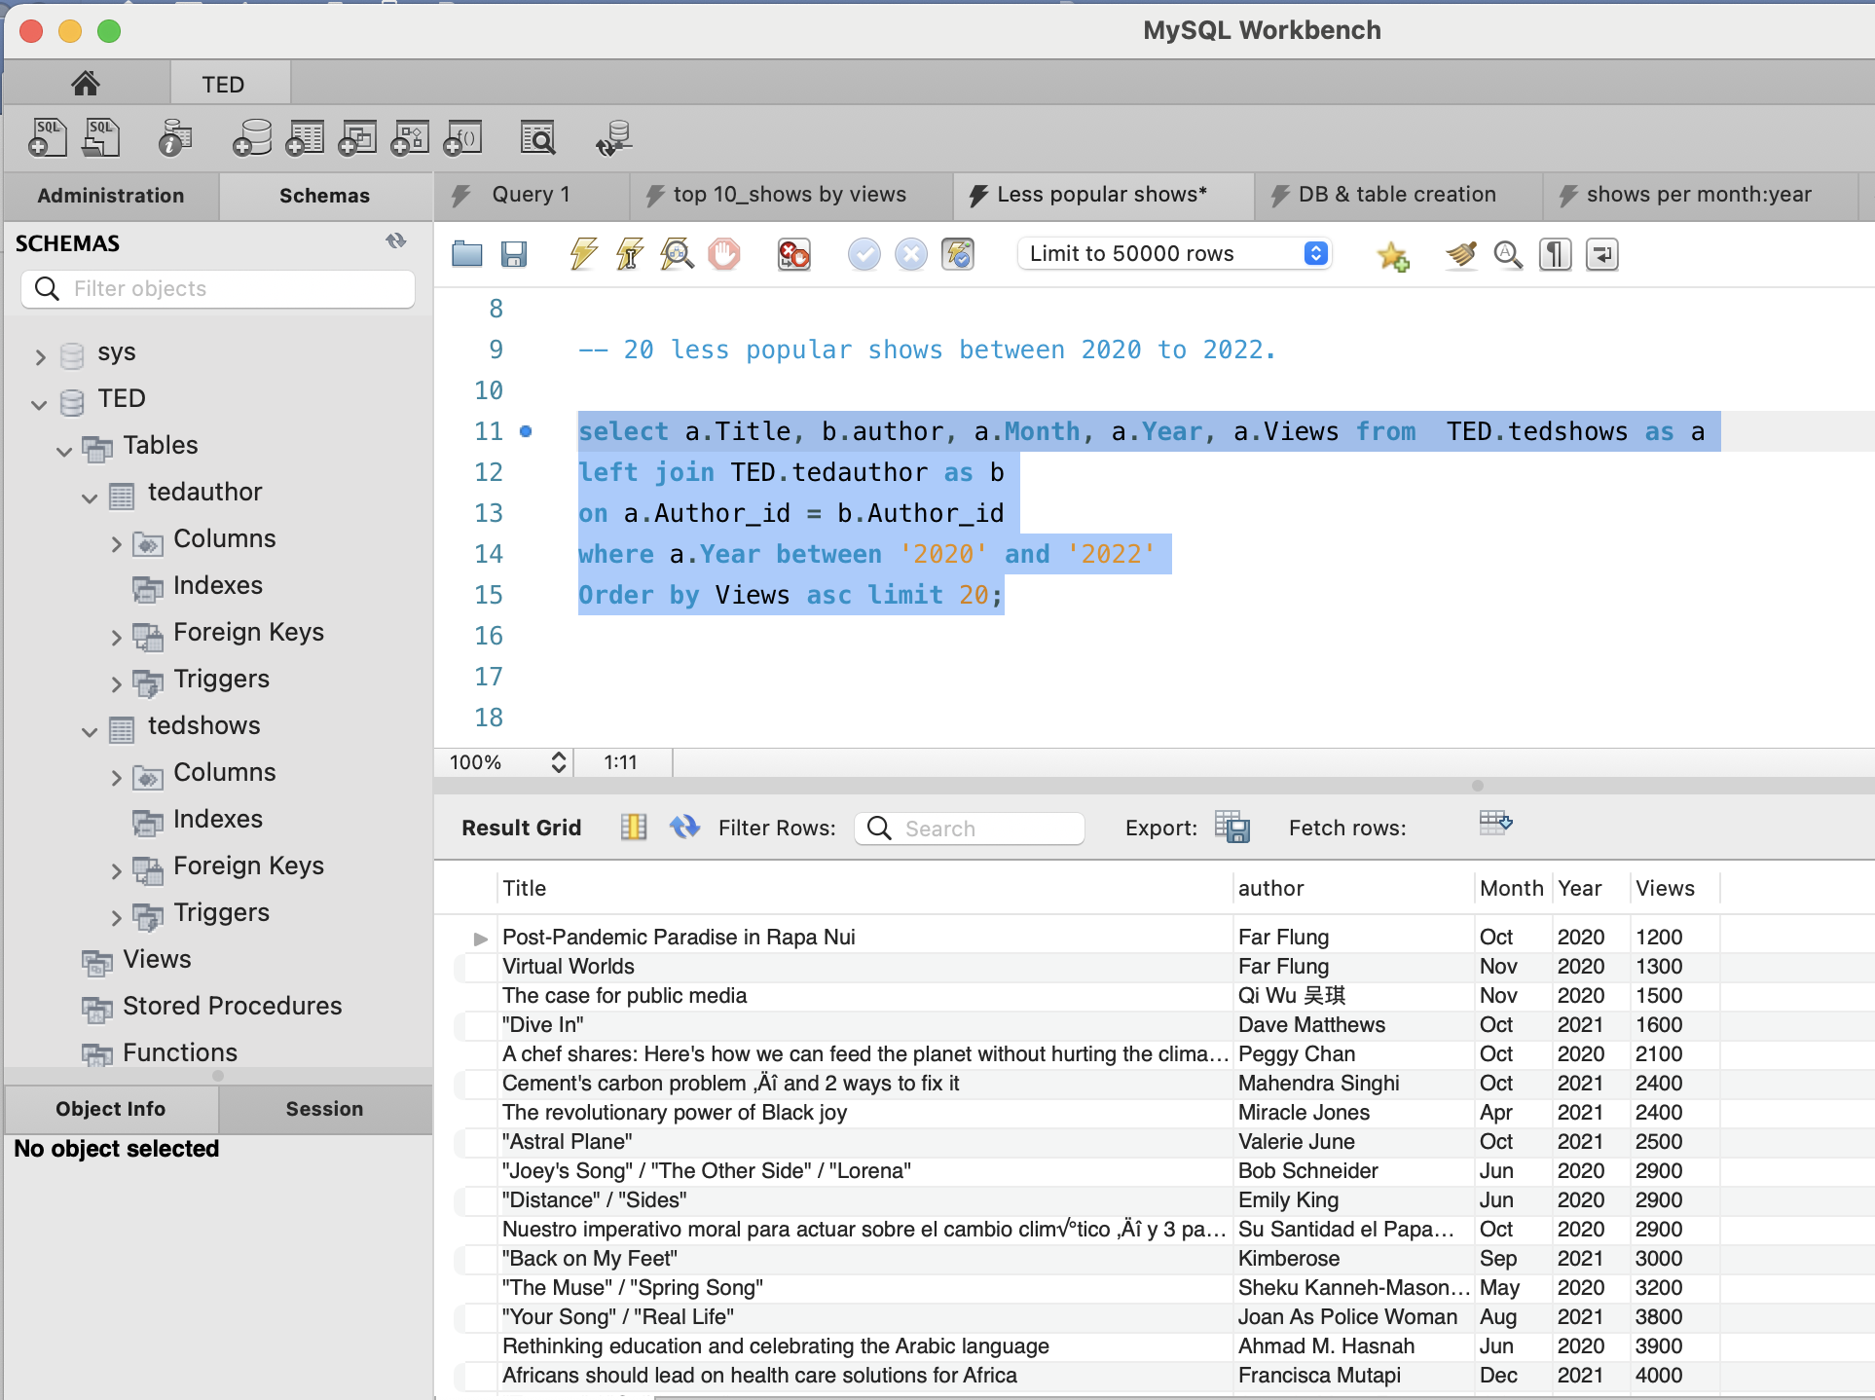

Query6: total number of shows per month

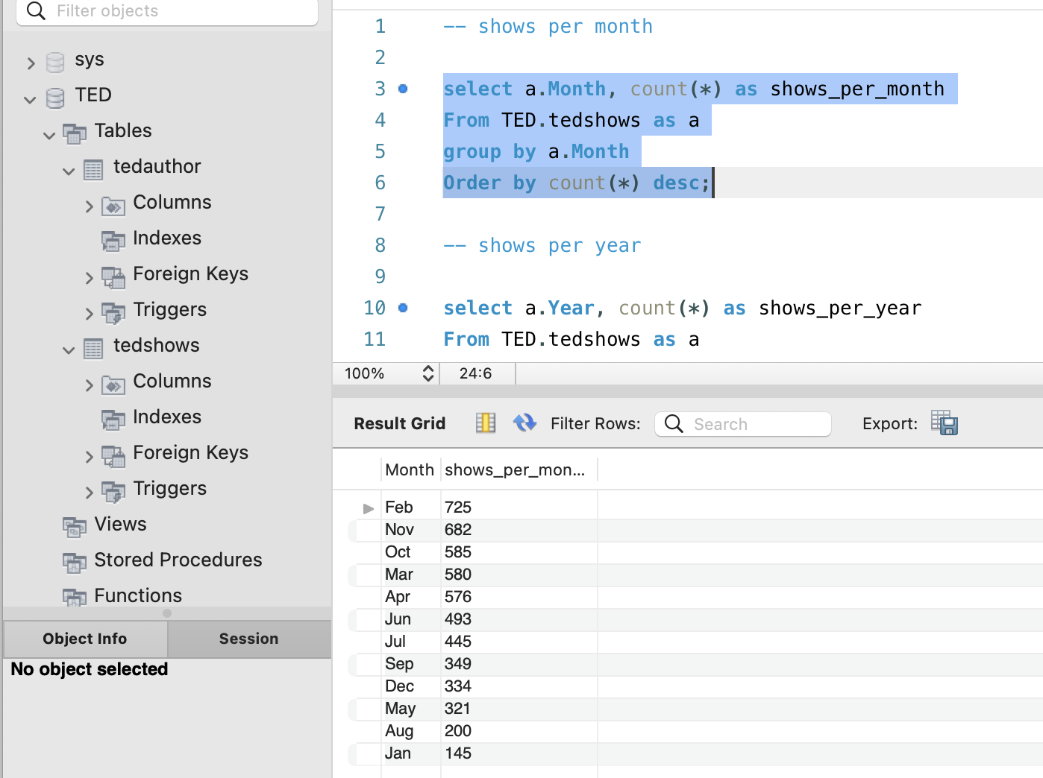

Query7: total number of shows per year.

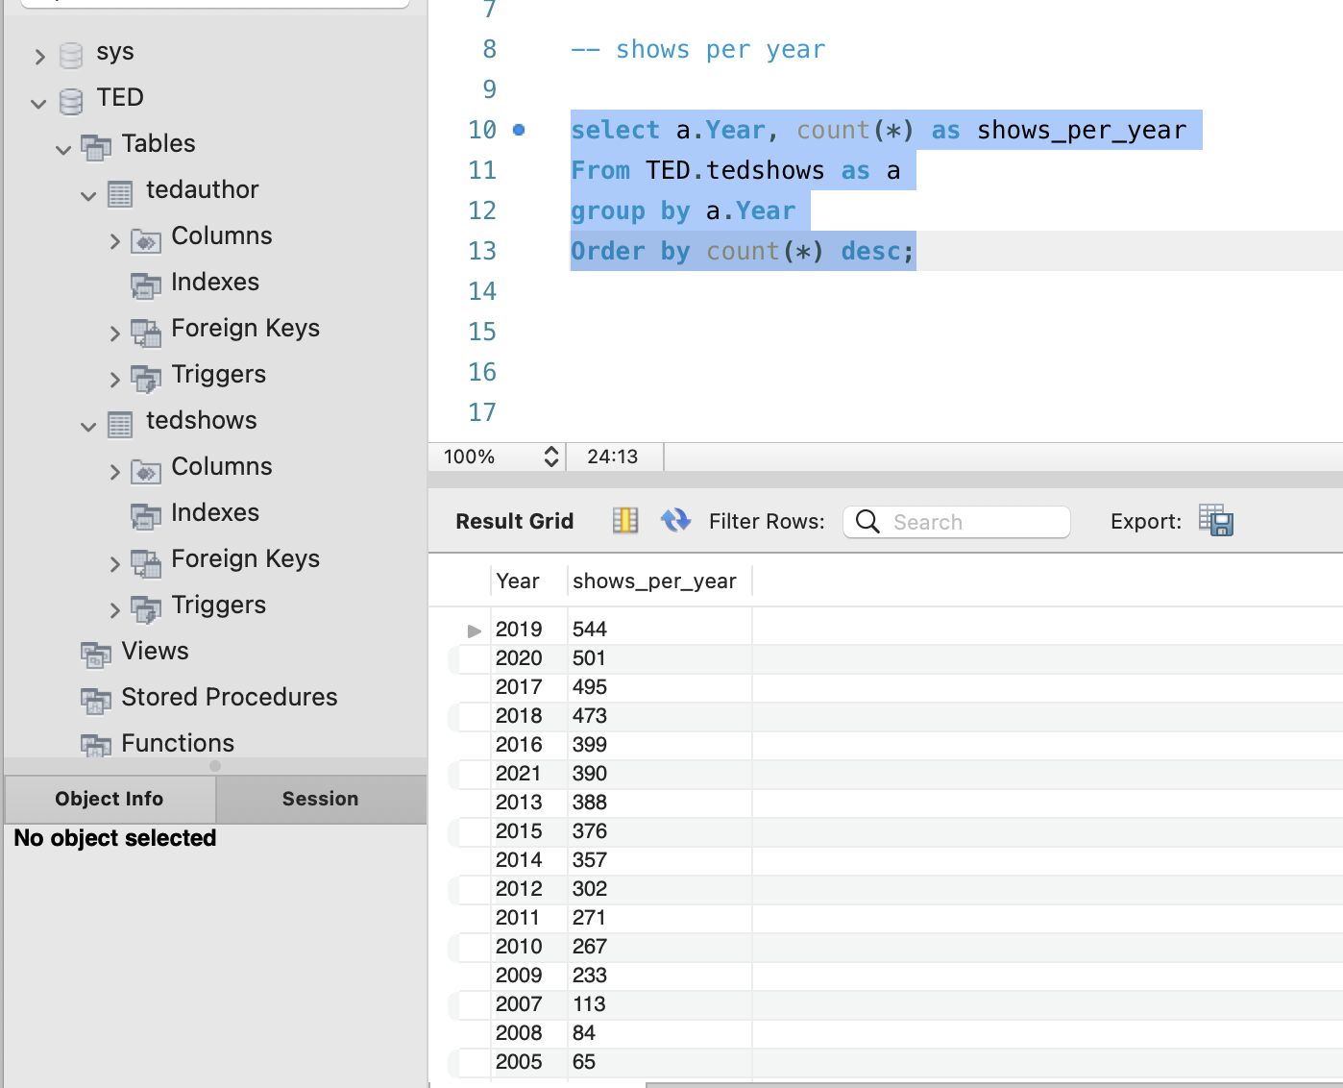

Query8: shows which has more than 1 author.

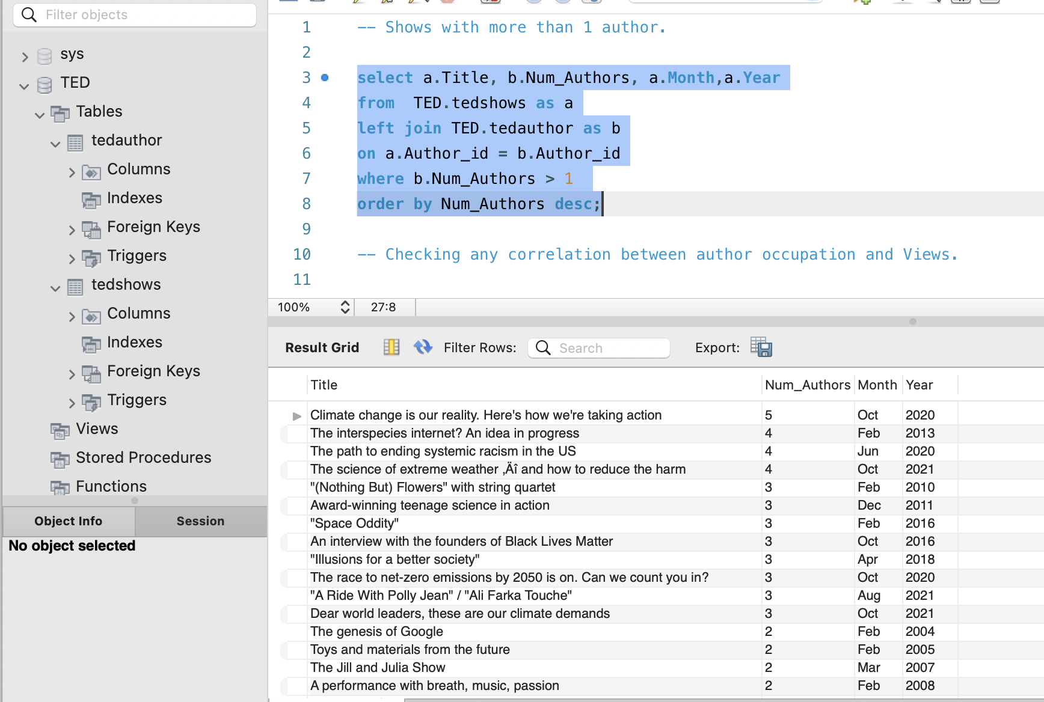

Query9: author occupation has any relation with the views and likes.

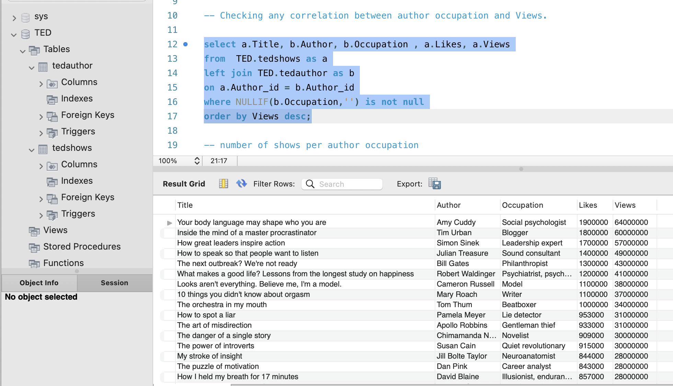

Query10: Number of shows per author occupation.

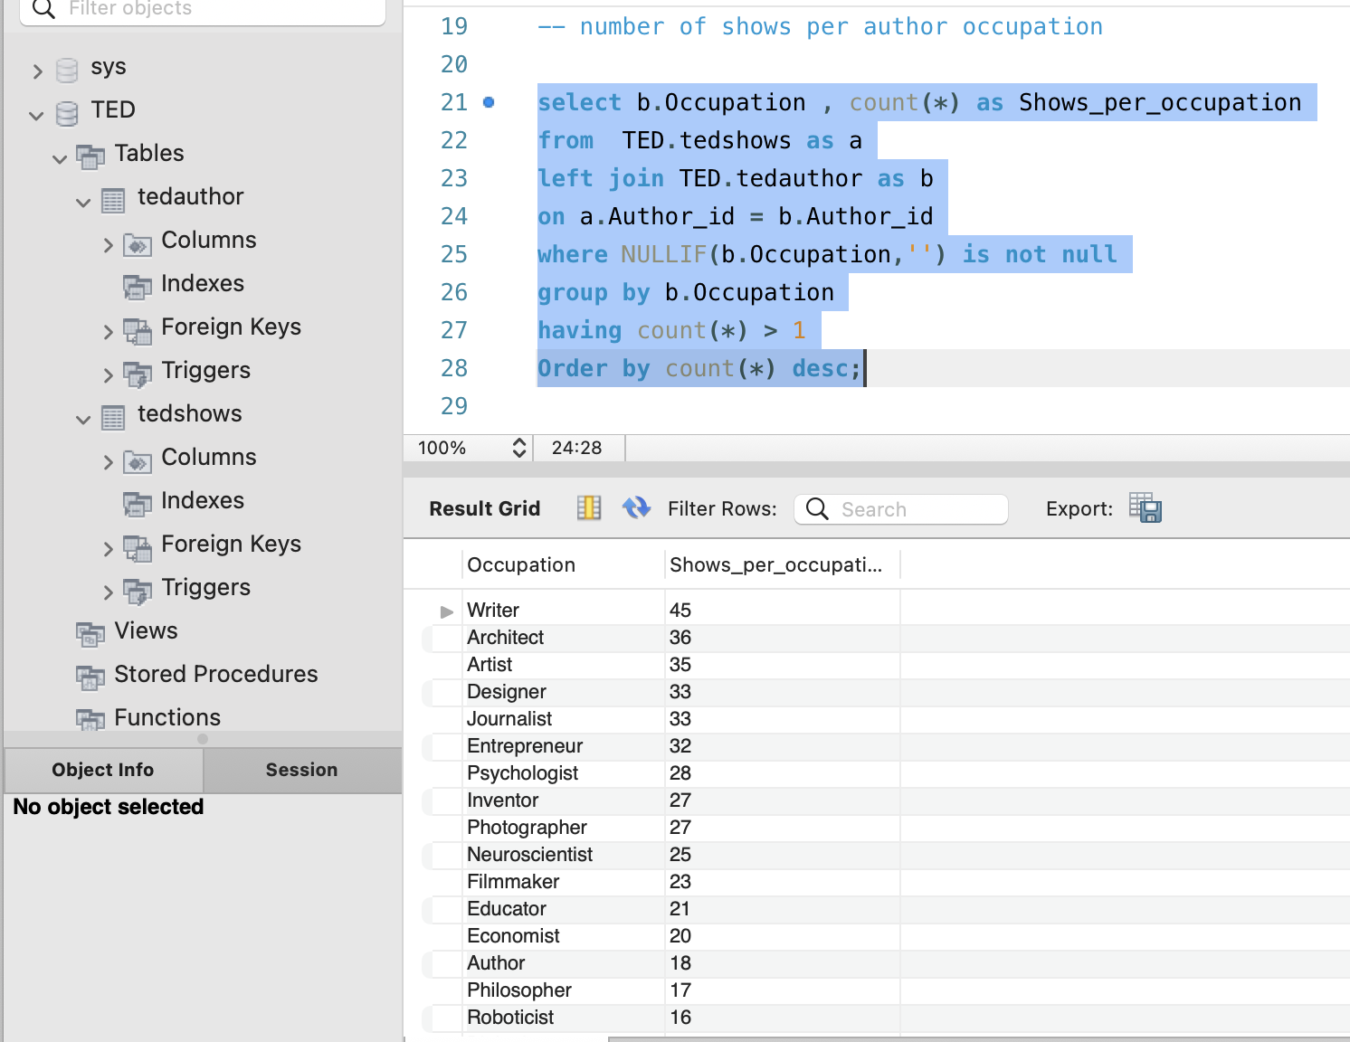

Query11: Total number of shows per num_authors

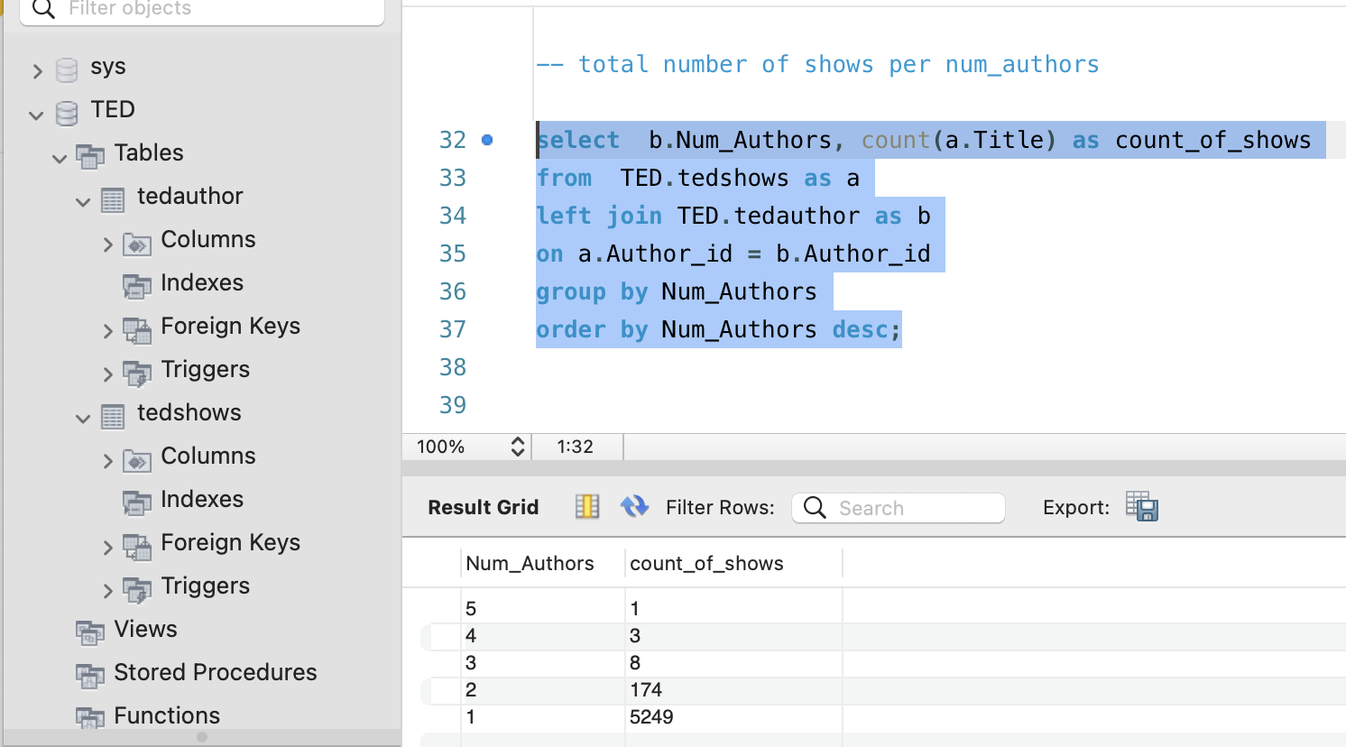

Query12: Total number of shows per num_authors, years.

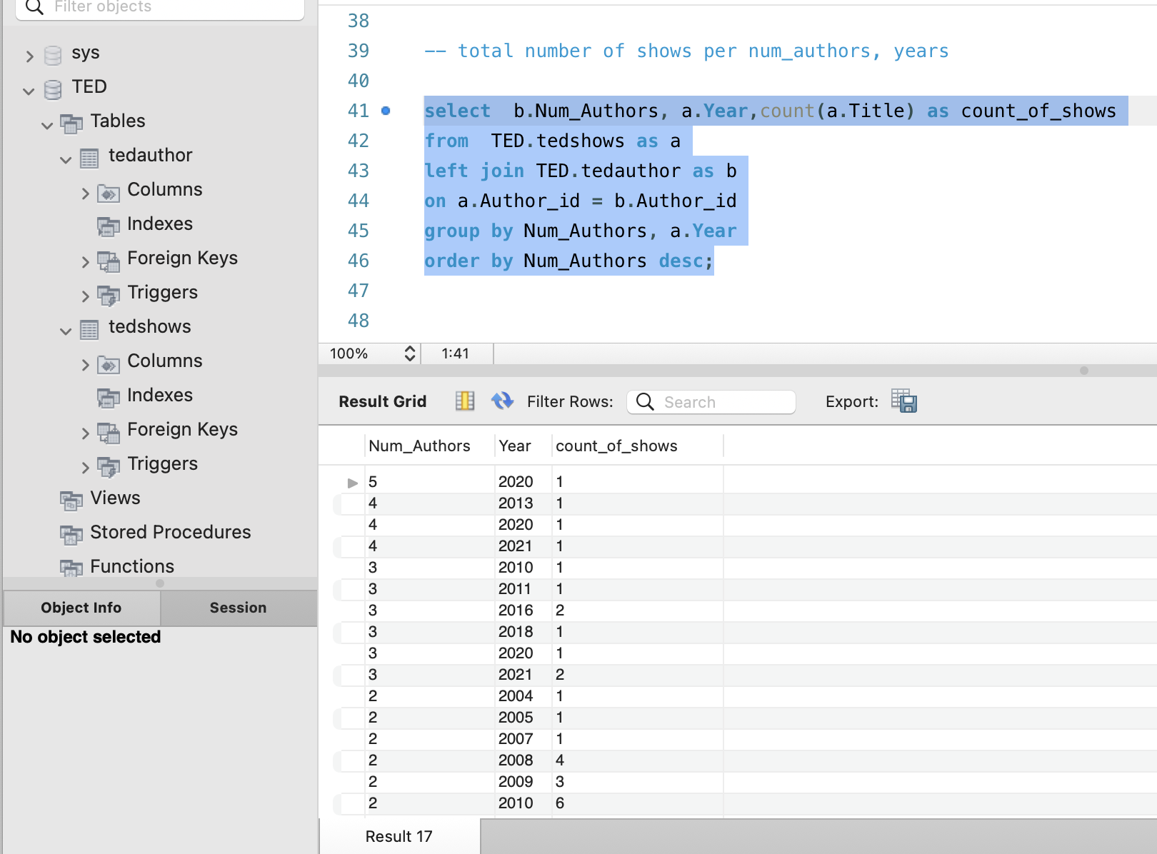

Query13: avg number of likes per year

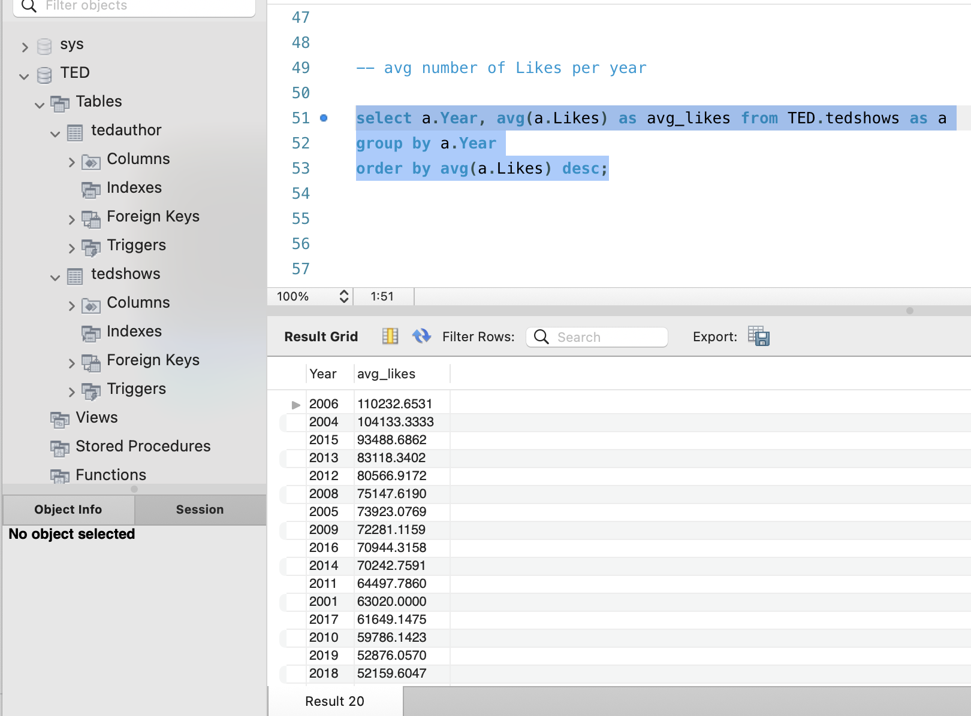

Query14: Avg number of views per year

